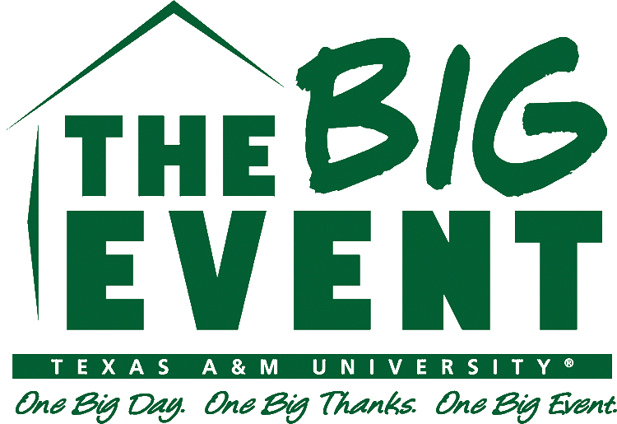
Staff Assistant Application
2018-2019
bigevent.tamu.edu

Howdy! Thank you for your interest in applying for Big Event 2019 Staff Assistant! Your desire to be more involved in this organization’s mission of saying “Thank You” to the Bryan/College Station community is a direct reflection of the Aggie core value of selfless service. A leadership position of this type can be demanding of your time, so please consider other previous commitments before applying. Listed below are mandatory dates for staff assistants. Dues for the spring will also be required in order to cover general expenses.

If the cost of membership is too burdensome, assistance is available. Ms. Kelly Boatright, a former director of The Big Event, has given a generous donation to help fund scholarships for those in need of financial assistance with their dues.

Fall Semester | Spring Semester
- Weekly Meetings: 7:30 p.m. every Tuesday  - Staff Social: November 6th | - Weekly Meetings: 7:30 p.m. every Tuesday  - Office Hours: 1 every other week  - Spring Kickoff & JRF Distribution: Saturday, January 19th  - 15- 20 Job Site Checks  - The Big Event March 30th, 2019  - Spring Dues: $50.00

Each applicant is required to attend one of our informationals. Each informational will last around 30 minutes. Highlight the informational that you attended. If you cannot attend any of the informationals, please email development@bigevent.tamu.edu.

Monday, Oct. 22nd - 7:00 PM, Rudder 301 Tuesday, Oct. 23rd- 7:00 pm Rudder 301
Wednesday, Oct. 24th- 7:00 pm Rudder 301 Thursday, Oct. 25th- 7:00 pm Rudder 301

Applications are due online by Friday, October 26th at 5:00 PM. Results and interview sign-ups will be sent via email by 8 PM on Sunday, October 28th. Interviews will occur Monday, October 29th through Friday, November 2nd.

Name: ______________________________________ UIN: ____________________________________

Official TAMU Email: _____________________________ Preferred Email: ________________________

Preferred Phone Number: ________________________ Birthday: _________________

GPR > 2.0 (y/n) ____ Last Semester GPR> 2.0? (y/n) ____ Graduation Date: __________ Polo Size: _______

Essay Questions: Please answer these questions in a separate Word Document, and include this file in your application online in PDF format. Keep your answer to each question under 250 words Please include your UIN in the top right corner of the page, and do not include your name in the word file or on the document.

- Why do you want to be a staff assistant?
- What makes a good staff assistant partner?
- If you were a tool, what kind of tool would you be?

The Student Government shall not discriminate against, nor give preferential treatment to, any person on the basis of race, color, national or ethnic origin, religion, sex, gender, disability, age, sexual orientation, or veteran status. Big Event’s admissions process can be found in Chapter 104, Article 2, Section 2 of the SGA Code. You have the right to appeal any committee decision to The Judicial Court.
I understand that as an applicant for a committee, commission, or other position in SGA my grades will be checked prior to selection.

____________________________________ _________________________________ ___________________
Name Signature/Initial Date

